List of API endpoints used

// PRODUCTS
GET /products
GET /products/:id
POST /products
PUT /products/:id
DELETE /products/:id

// SUPPLIERS
GET /suppliers
GET /suppliers/:id
POST /suppliers
PUT /suppliers/:id
DELETE /suppliers/:id

// ORDERS
GET /orders
GET /orders/:id
POST /orders

API_BASE_URL

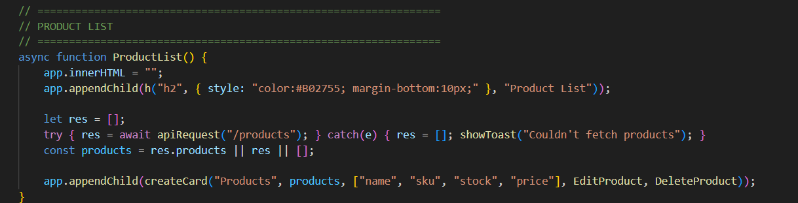
PRODUCT LIST

ADD PRODUCT
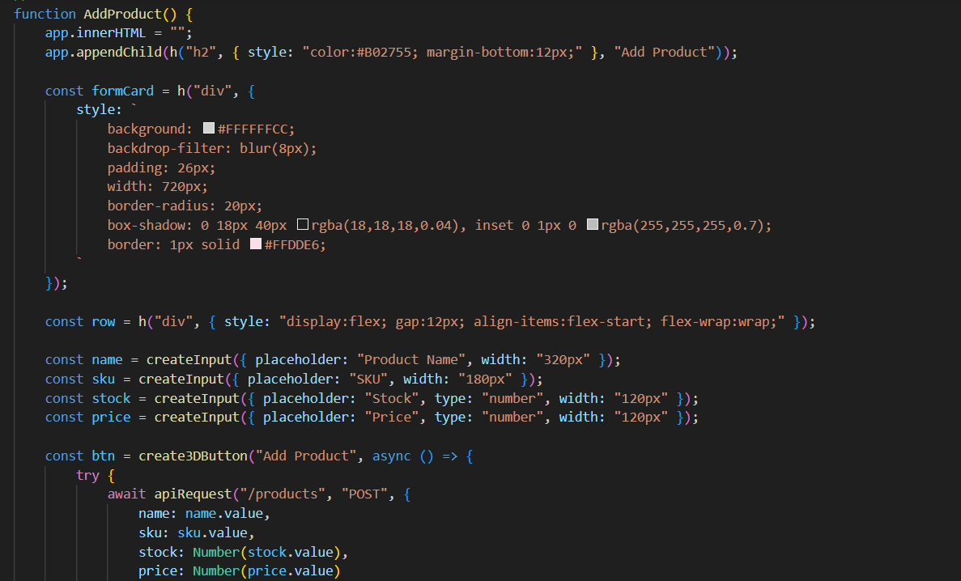

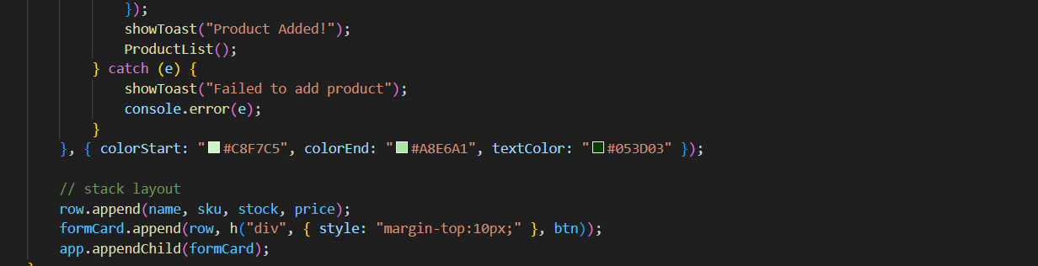
EDIT PRODUCT
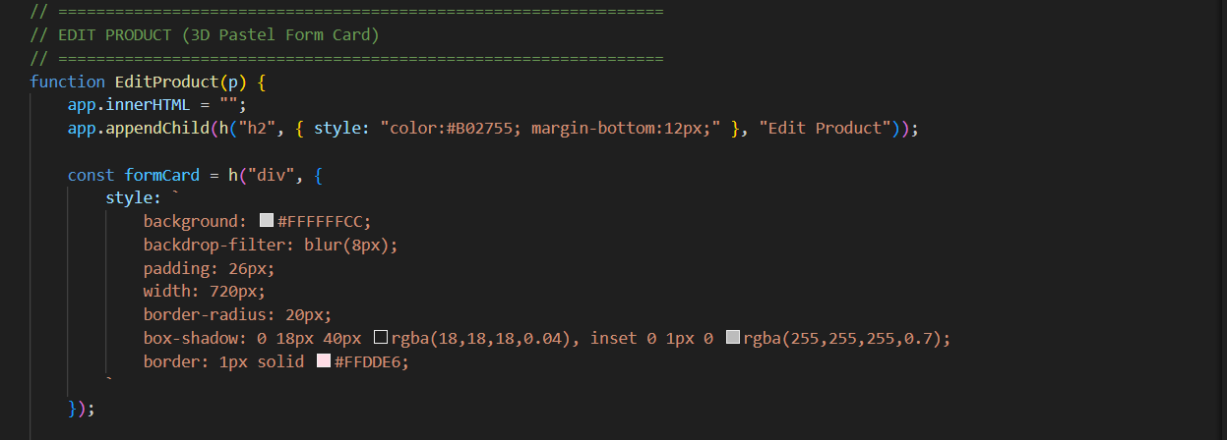
DELETE PRODUCT
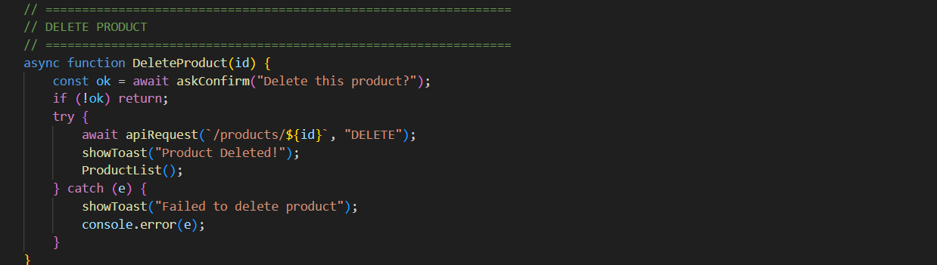

SUPPLIER LIST
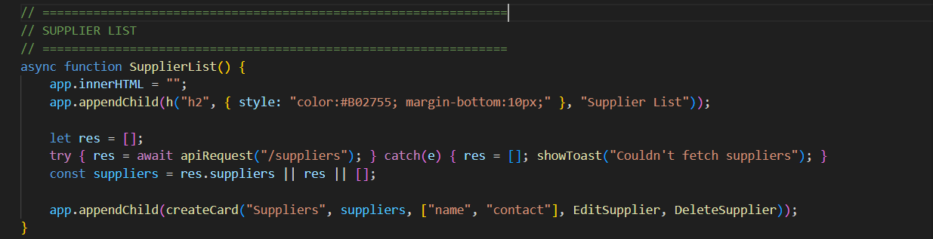
ADD SUPPLIER
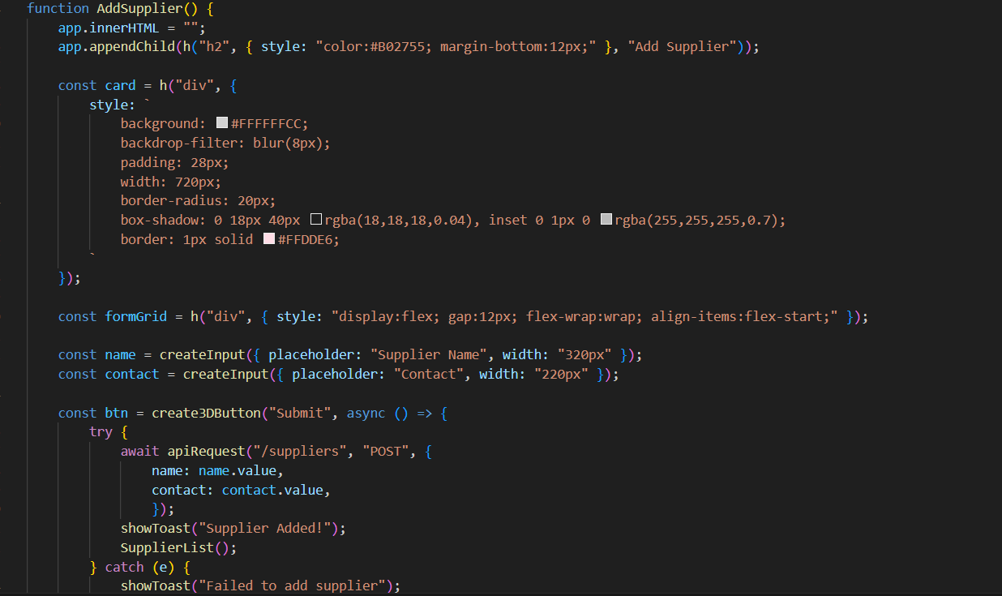


EDIT SUPPLIER
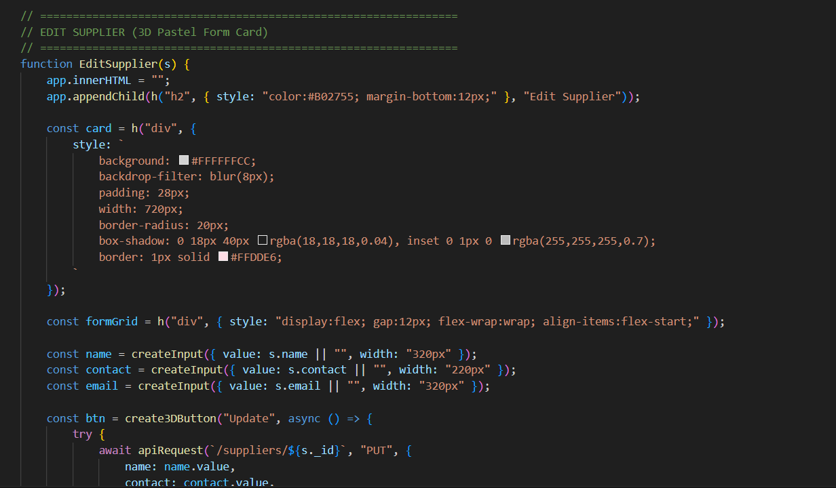

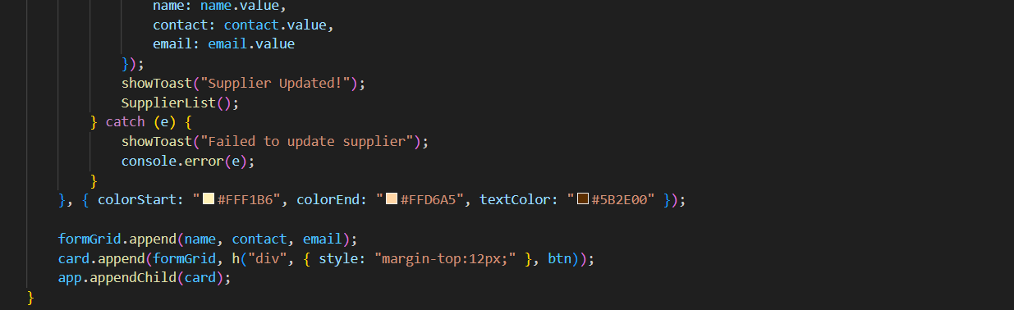
DELETE SUPPLIER
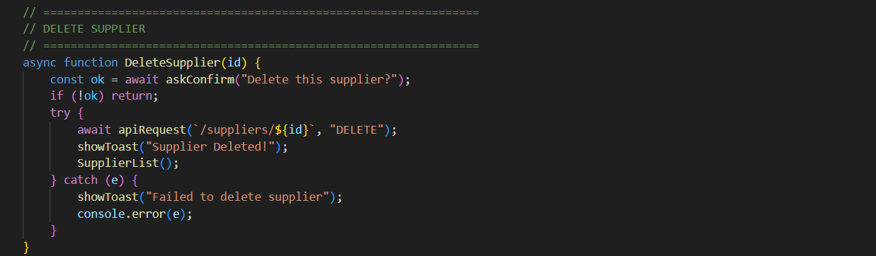

ORDER LIST
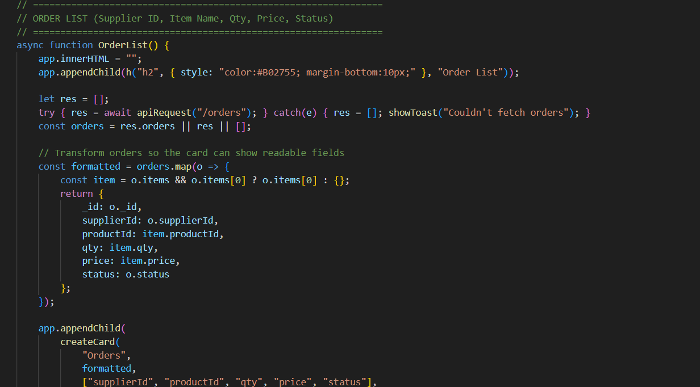
EDIT ORDER
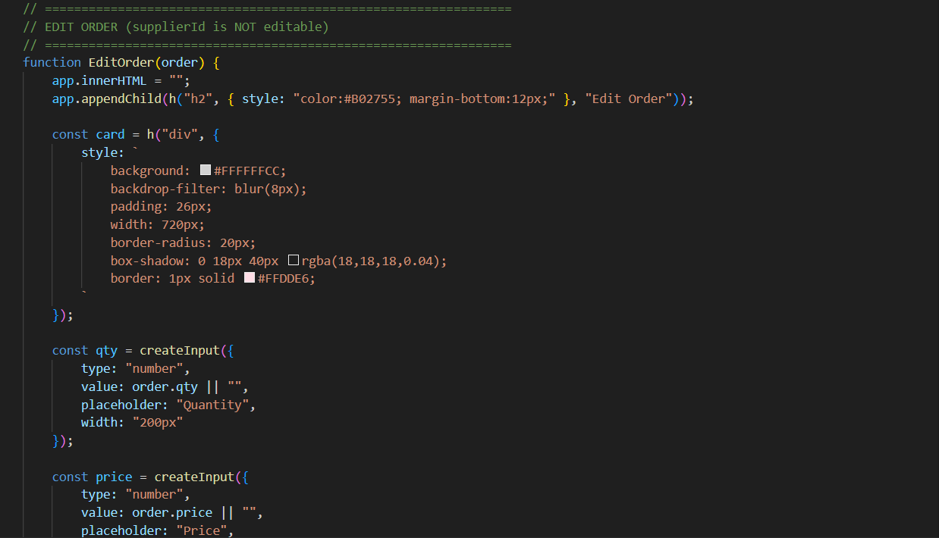
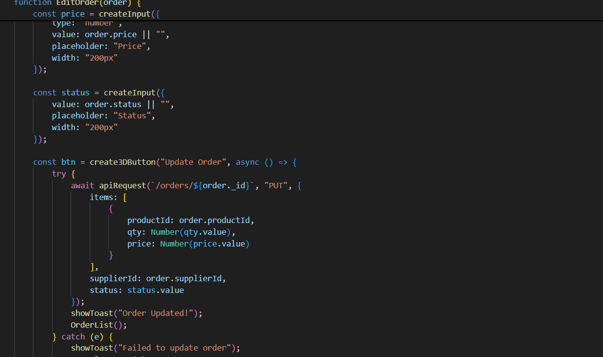
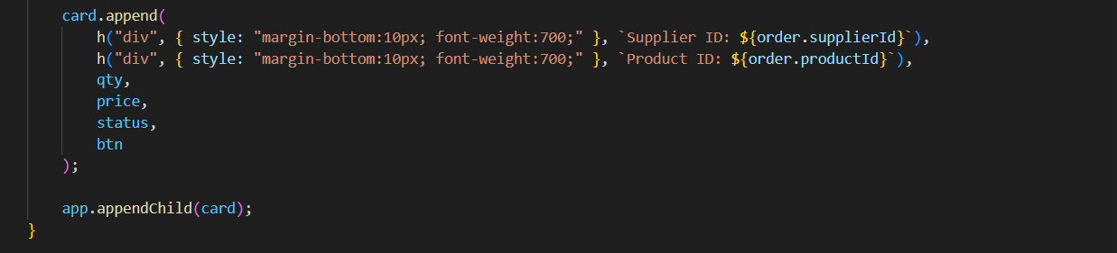
DELETE ORDER
